**OUTPUT**

**Google Chrome Browser:**

**RENT below 60000:**

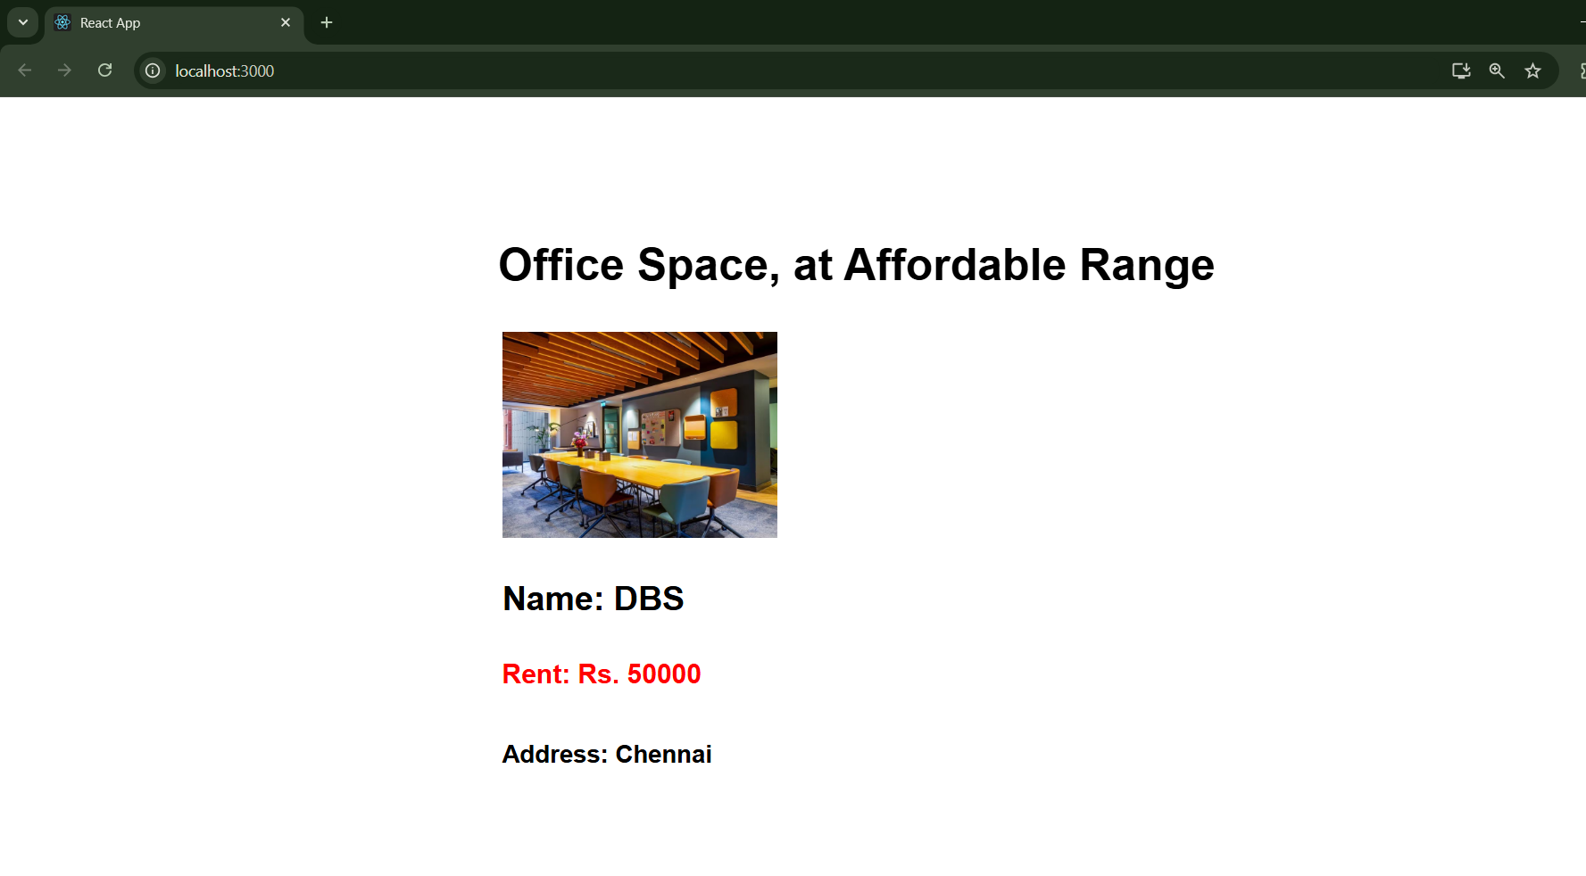

**RENT above 60000:**

